HAS

Q3 University of California at Berkeley
CONSENT TO PARTICIPATE IN RESEARCH
My name is Don Moore. I am a professor at the Haas School. I would like to invite you to take part in my research study which examines visual perception.
If you agree to take part, you will be asked to respond to a short survey. You will see pictures of people and you will guess how much they weigh. You will also take a short test of visual pattern-matching. The entire exercise should take less than thirty minutes.
There is no direct benefit to you anticipated from participating in this study. However, it is hoped that the information gained from the study will help us better understand come to have confidence in their judgments. And we will be happy to send you feedback about your performance in the study if you like.
There is little risk to you from taking part in this research. As with all research, there is a chance that confidentiality could be compromised; however, we are taking precautions to minimize this risk. Your study data will be handled as confidentially as possible.
Please understand that participation in research is completely voluntary. You are free to decline to take part in the project. You can decline to answer any questions and are free to stop taking part in the project at any time. Whether or not you choose to participate in the research and whether you choose to answer a question or continue participating in the project, there will be no penalty to you.
If you have any questions about the research, you may telephone me, Don Moore at (510) 642-1059 or contact me by e-mail at dmoore@haas.berkeley.edu.
If you have any question regarding your treatment or rights as a participant in this research project, please contact the University of California at Berkeley’s Committee for Protection of Human Subjects at (510) 642-7461, subjects@berkeley.edu.
************************************************************
If you agree to take part in the research, please click the “accept” button below.
By accepting, you certify that you are 18 years or older. You have read this consent form and agree to take part in this research.
- Accept (1)

Q35 In what year were you born?

Q7 We want to reward you for doing well guessing weights: The more accurate your answers are, the greater chance you have to win our prize, a Berkeley-Haas sweatshirt.
Each correct guess increases your entries into the drawing. Since you will be guessing the ten peoples' weights, getting every weight that you get correct will earn you 10 entries into the prize lottery.

Q9 Attention: Important information.
You will be guessing the weights of 10 different people. If your guess is within 40 lbs of the actual weight, it is considered a "correct" answer. 41 or more pounds counts as wrong.

Q57 If you think in kilograms, recall that there are 2.2 lbs per kilogram.
Proceed to the next page to start guessing weights.

Q57 Attention: Important information.
You will be guessing the weights of 10 different people. If your guess is within 3 lbs of the actual weight, it is considered a "correct" answer. 4 or more pounds counts as wrong.

Q55 If you think in kilograms, recall that there are 2.2 lbs per kilogram.
Proceed to the next page to start guessing weights.

Q13
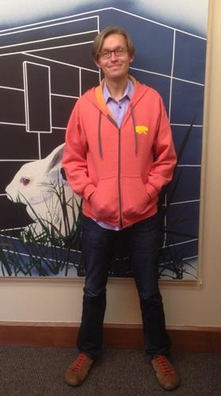

Q15 How much does this person weigh? (in pounds)
Remember, 1 kilogram = 2.2 pounds

Q17
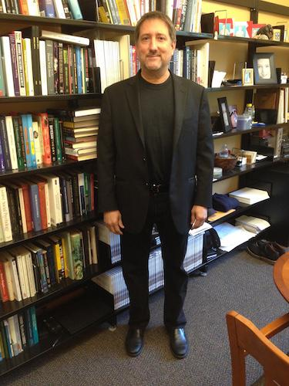

Q19 How much does this person weigh? (in pounds)

Q21
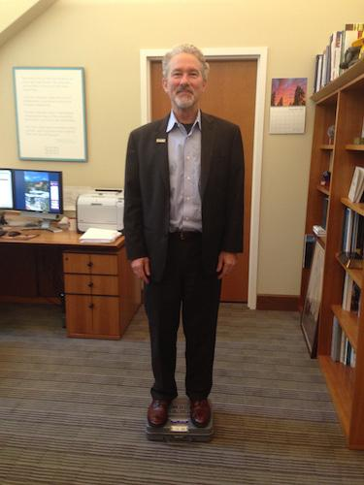

Q23 How much does this person weigh? (in pounds)Remember, 1 kilogram = 2.2 pounds

Q25
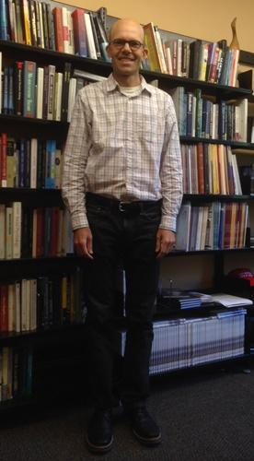

Q27 How much does this person weigh? (in pounds)Remember, 1 kilogram = 2.2 pounds

Q29
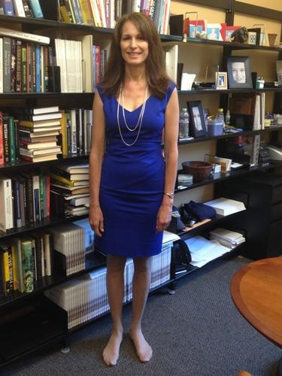

Q31 How much does this person weigh? (in pounds)Remember, 1 kilogram = 2.2 pounds

Q33
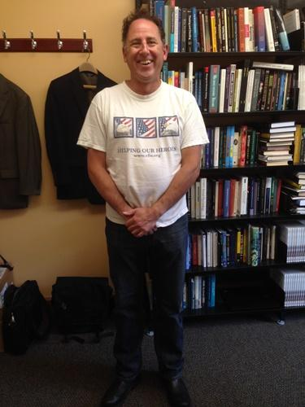

Q35 How much does this person weigh? (in pounds)Remember, 1 kilogram = 2.2 pounds

Q37
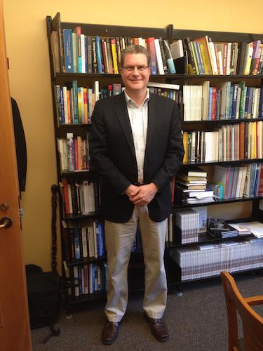

Q39 How much does this person weigh? (in pounds)Remember, 1 kilogram = 2.2 pounds

Q41

Q43 How much does this person weigh? (in pounds)Remember, 1 kilogram = 2.2 pounds

Q45
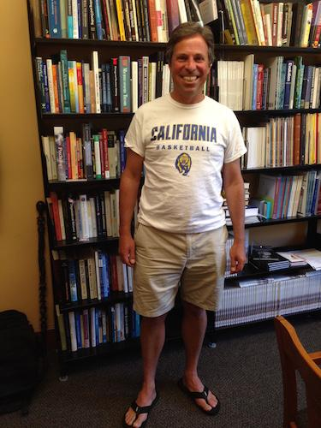

Q47 How much does this person weigh? (in pounds)Remember, 1 kilogram = 2.2 pounds

Q49
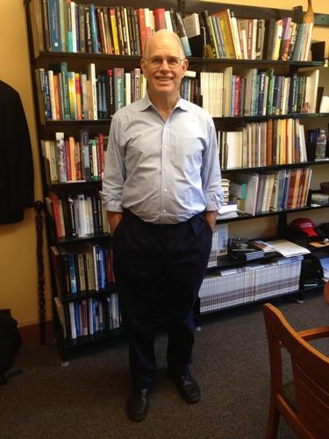

Q51 How much does this person weigh? (in pounds)Remember, 1 kilogram = 2.2 pounds

Q52 Remember that an answer counts as correct if it is within 40 pounds of the right answer. We want to know how you think you did.
Please tell us how likely it is that you got each of the possible scores below on the survey by dragging the bar to the desired location.
______ Zero right (1)
______ 1 right, 9 wrong (2)
______ 2 right, 8 wrong (3)
______ 3 right, 7 wrong (4)
______ 4 right, 6 wrong (5)
______ 5 right, 5 wrong (6)
______ 6 right, 4 wrong (7)
______ 7 right, 3 wrong (8)
______ 8 right, 2 wrong (9)
______ 9 right, 1 wrong (10)
______ All 10 right (11)

Q59 Remember that an answer counts as correct if it is within 3 pounds of the right answer. We want to know how you think you did. Please tell us how likely it is that you got each of the possible scores below on the survey by dragging the bar to the desired location.
______ Zero right (1)
______ 1 right, 9 wrong (2)
______ 2 right, 8 wrong (3)
______ 3 right, 7 wrong (4)
______ 4 right, 6 wrong (5)
______ 5 right, 5 wrong (6)
______ 6 right, 4 wrong (7)
______ 7 right, 3 wrong (8)
______ 8 right, 2 wrong (9)
______ 9 right, 1 wrong (10)
______ All 10 right (11)

Q54 We have randomly selected one other participant out of the other Berkeley-Haas alumni who have also completed this survey. Please tell us how you think that person did. Specifically, we need you to tell us how likely it is that that randomly selected person got each of the possible scores below.
______ Zero right (1)
______ 1 right, 9 wrong (2)
______ 2 right, 8 wrong (3)
______ 3 right, 7 wrong (4)
______ 4 right, 6 wrong (5)
______ 5 right, 5 wrong (6)
______ 6 right, 4 wrong (7)
______ 7 right, 3 wrong (8)
______ 8 right, 2 wrong (9)
______ 9 right, 1 wrong (10)
______ All 10 right (11)

Q88
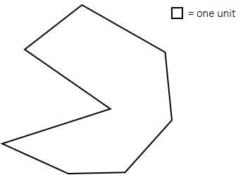

Q90 Your challenge is to try to estimate the area of the shape above. The little box in the top right is one unit of area.

Q92 Approximately how many of those little boxes could fit inside the big shape?

Q94 How likely do you think it is that your answer is within 10 units (above or below) of the actual area? Move the slider to indicate your level of confidence (0 means no chance, 100 means absolutely certain)
______ 1 (1)

Q96 Estimate a number so low that there is a 5% chance the actual area is smaller.

Q98 Estimate a number so high that there is a 5% chance the actual area is larger.

Q67 For the second part of this survey, there are nine items. For each of the following items, select one of the options that best completes the pattern:

Q70
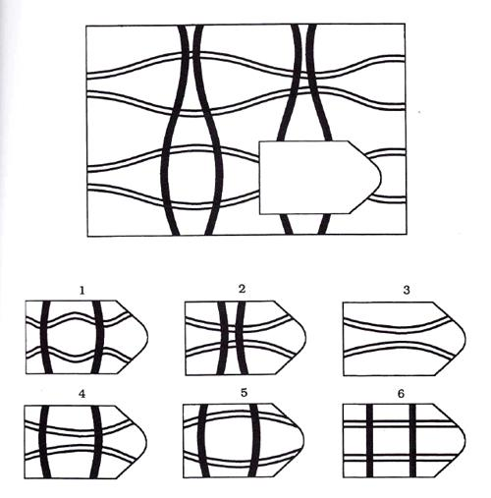

Q71 Which of the options best completes the pattern?
- 1 (1)
- 2 (2)
- 3 (3)
- 4 (4)
- 5 (5)
- 6 (6)

Q72
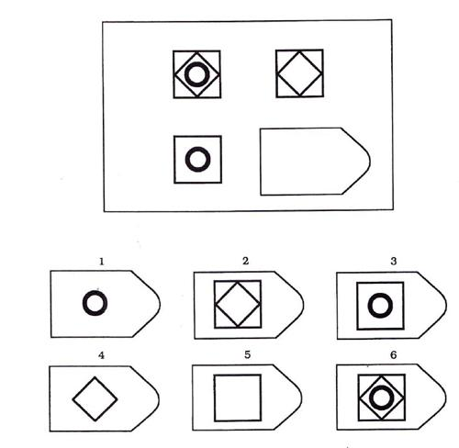

Q73 Which of the options best completes the pattern?
- 1 (1)
- 2 (2)
- 3 (3)
- 4 (4)
- 5 (5)
- 6 (6)

Q74
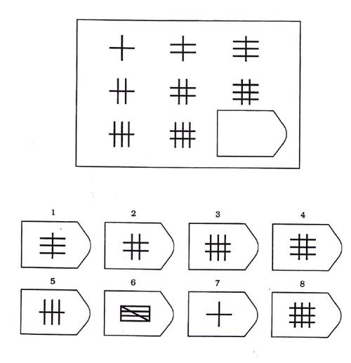

Q75 Which of the options best completes the pattern?
- 1 (1)
- 2 (2)
- 3 (3)
- 4 (4)
- 5 (5)
- 6 (6)
- 7 (7)
- 8 (8)

Q78
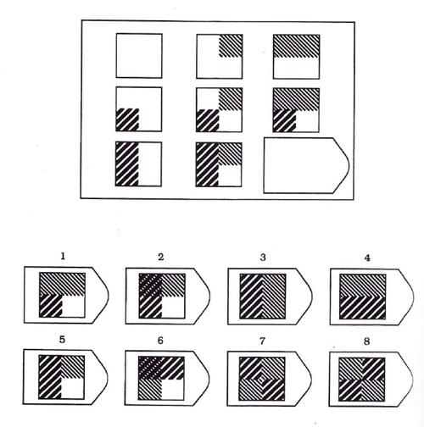

Q76 Which of the options best completes the pattern?
- 1 (1)
- 2 (2)
- 3 (3)
- 4 (4)
- 5 (5)
- 6 (6)
- 7 (7)
- 8 (8)

Q80
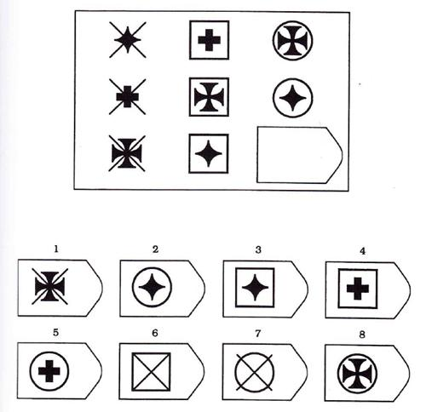

Q77 Which of the options best completes the pattern?
- 1 (1)
- 2 (2)
- 3 (3)
- 4 (4)
- 5 (5)
- 6 (6)
- 7 (7)
- 8 (8)

Q81
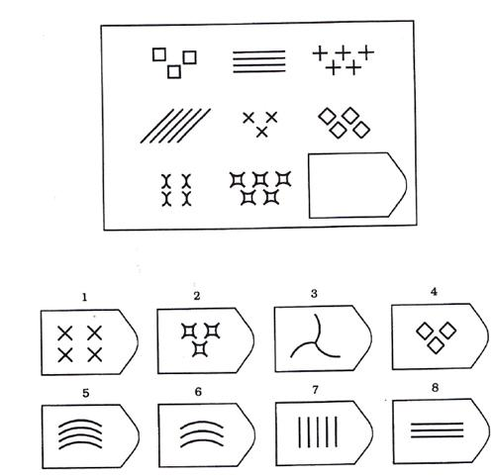

Q79 Which of the options best completes the pattern?
- 1 (1)
- 2 (2)
- 3 (3)
- 4 (4)
- 5 (5)
- 6 (6)
- 7 (7)
- 8 (8)

Q84
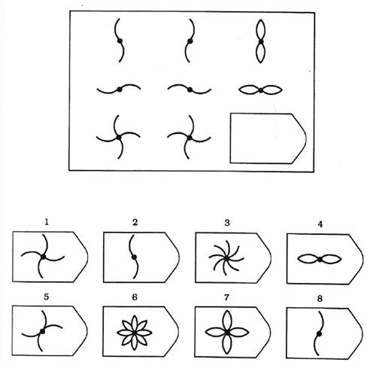

Q82 Which of the options best completes the pattern?
- 1 (1)
- 2 (2)
- 3 (3)
- 4 (4)
- 5 (5)
- 6 (6)
- 7 (7)
- 8 (8)

Q85
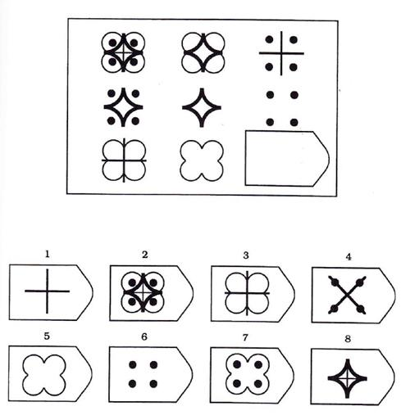

Q83 Which of the options best completes the pattern?
- 1 (1)
- 2 (2)
- 3 (3)
- 4 (4)
- 5 (5)
- 6 (6)
- 7 (7)
- 8 (8)

Q87
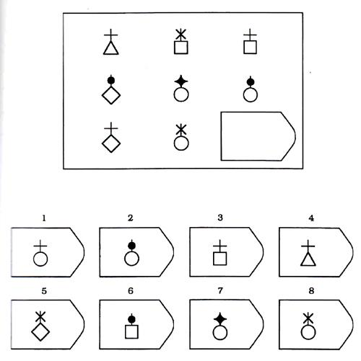

Q86 Which of the options best completes the pattern?
- 1 (1)
- 2 (2)
- 3 (3)
- 4 (4)
- 5 (5)
- 6 (6)
- 7 (7)
- 8 (8)

Q68 What is YOUR age (in years)?

Q70 What is your gender?
- Female (1)
- Male (2)
- Other (3)

Q92 Would you like us to send you feedback regarding your performance on the tasks in this study?
- Yes (5)
- No (6)

Q66 Please enter your email address here if you would like to receive feedback, and so we can contact you if you win the prize. We will not use your email for any other purpose. (If you do not wish to be entered into the lottery for the prize and you are not interested in receiving feedback, you may skip this.)

Q72 Anything else you would like to tell us about this survey or your answers?

Q74 Thank you for taking this survey!

