OOLS 2

Q3 University of California at Berkeley
CONSENT TO PARTICIPATE IN RESEARCH
My name is Don Moore, I am a professor at the Haas School of Business at the University of California at Berkeley. I would like to invite you to take part in my research study which examines how people estimate.
If you agree to take part, you will be asked to respond to a short survey. You will be asked to estimate some values. The entire exercise should take less than twenty minutes and you will be paid for your participation via Amazon mTurk.
There is no direct benefit to you anticipated from participating in this study. However, it is hoped that the information gained from the study will help us better understand how people learn to make better forecasts, what questions are best for eliciting problems, what training interventions are most helpful, and which aggregation techniques are most effective for maximizing accuracy. There is little risk to you from taking part in this research. As with all research, there is a chance that confidentiality could be compromised; however, we are taking precautions to minimize this risk.
Your study data will be handled as confidentially as possible. Amazon’s system codes the data with ID numbers so that each participant’s answers cannot be linked to their identities.
Please understand that participation in research is completely voluntary. You are free to decline to take part in the project. You can decline to answer any questions and are free to stop taking part in the project at any time. Whether or not you choose to participate in the research and whether or not you choose to answer a question or continue participating in the project, there will be no penalty to you or loss of benefits to which you are otherwise entitled.
If you have any questions about the research, you may telephone me, Don Moore at (510) 642-1059 or contact me by e-mail at dmoore@haas.berkeley.edu.
If you have any question regarding your treatment or rights as a participant in this research project, please contact the University of California at Berkeley’s, Committee for Protection of Human Subjects at (510) 642-7461, subjects@berkeley.edu.
************************************************************
If you agree to take part in the research, please click the “accept” button below.
By accepting, you certify that you are 18 years or older. You have read this consent form and agree to take part in this research.
- Accept (1)

Q35 In what year were you born?

Q7 We want to reward you for doing well guessing weights: The more accurate your answers are the greater chance you have to win a $30 prize.
Each correct guess increases your chances of winning the prize by 1%. Since you will be guessing the weights of 10 people, if you guess all their weights correctly then you earn a 10% chance at the $30 prize.

Q9 You will be guessing the weights of 10 different people. If your guess is within 40 lbs of the actual weight, it is considered a "correct" answer. 41 or more pounds counts as wrong.
If you think in kilograms, recall that there are 2.2 lbs per kilogram.
Proceed to the next page to start guessing weights.

Q57 You will be guessing the weights of 10 different people. If your guess is within 3 lbs of the actual weight, it is considered a "correct" answer. 4 or more pounds counts as wrong.
If you think in kilograms, recall that there are 2.2 lbs per kilogram.
Proceed to the next page to start guessing weights.

Q39 Before you move on to the survey on the next page, we want to check whether you have paid attention to the details and directions we gave you in the previous pages.
Please answer the following questions to move on to the weight-guessing task. If you do not answer the following questions correctly, you will not be able to move forward and finish the task.

Q40 How many people will you be guessing the weights of?

Q41 How many pounds do you have to guess within the actual weight in order for your answer to be considered "correct"?

Q48 Sorry. Because you failed an attention check, you are ineligible to complete the survey.

Q42 Before you move on to the survey on the next page, we want to check whether you have paid attention to the details and directions we gave you in the previous pages.Please answer the following questions to move on to the weight-guessing task. If you do not answer the following questions correctly, you will not be able to move forward and finish the task.

Q43 How many people will you be guessing the weights of?

Q44 How many pounds do you have to guess within the actual weight in order for your answer to be considered "correct"?

Q13
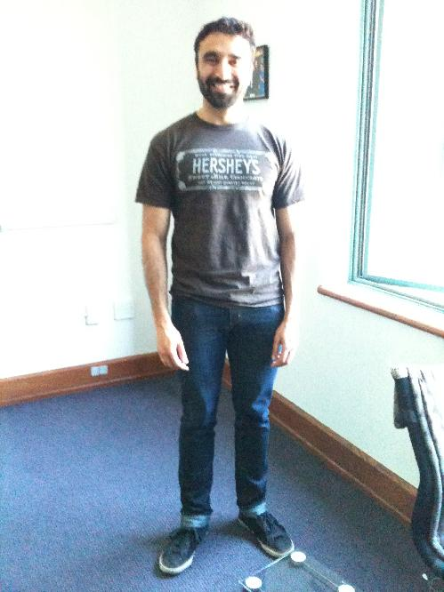

Q15 How much does this person weigh? (in pounds)

Q17

Q19 How much does this person weigh? (in pounds)

Q21
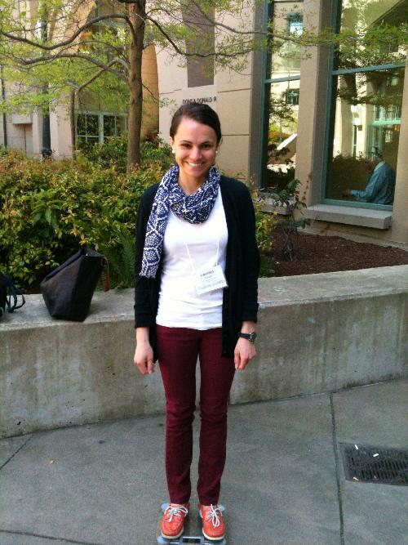

Q23 How much does this person weigh? (in pounds)

Q25
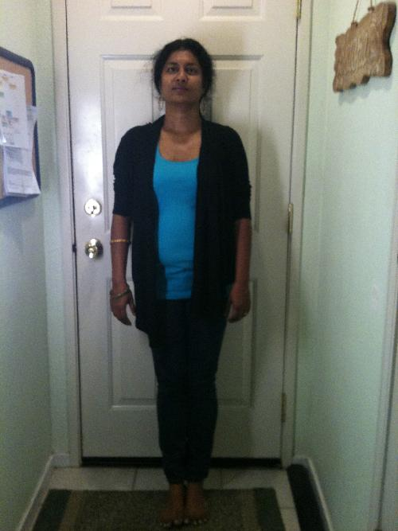

Q27 How much does this person weigh? (in pounds)

Q29
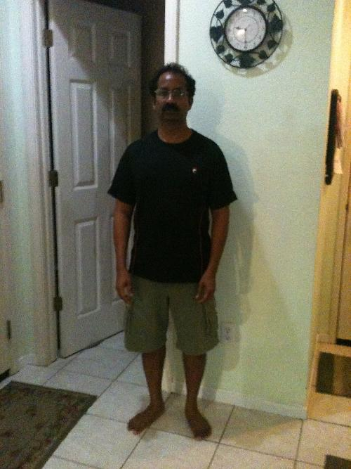

Q31 How much does this person weigh? (in pounds)

Q33

Q35 How much does this person weigh? (in pounds)

Q37

Q39 How much does this person weigh? (in pounds)

Q41
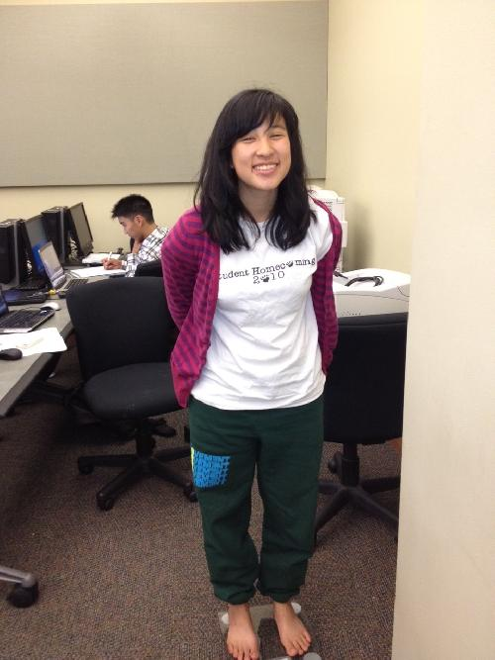

Q43 How much does this person weigh? (in pounds)

Q45
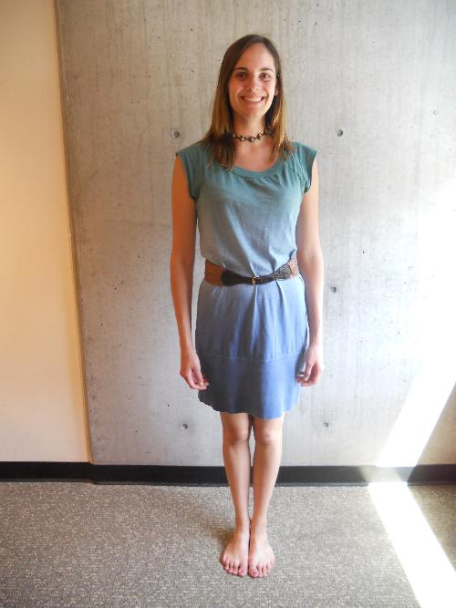

Q47 How much does this person weigh? (in pounds)

Q49
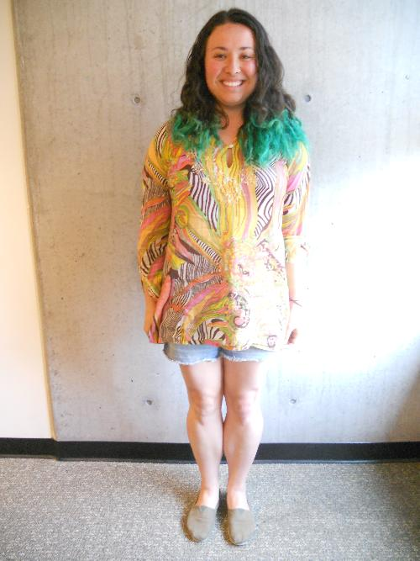

Q51 How much does this person weigh? (in pounds)

Q52 Remember that an answer counts as correct if it is within 40 pounds of the right answer. We want to know how you think you did. Please tell us how likely it is that you got each of the possible scores below on the survey by dragging the bar to the desired location.
______ Zero right (1)
______ 1 right, 9 wrong (2)
______ 2 right, 8 wrong (3)
______ 3 right, 7 wrong (4)
______ 4 right, 6 wrong (5)
______ 5 right, 5 wrong (6)
______ 6 right, 4 wrong (7)
______ 7 right, 3 wrong (8)
______ 8 right, 2 wrong (9)
______ 9 right, 1 wrong (10)
______ All 10 right (11)

Q45 As an incentive to answer this question accurately, we will be rewarding accurate responses using the quadratic scoring rule. For more details, click here.

Q59 Remember that an answer counts as correct if it is within 3 pounds of the right answer. We want to know how you think you did. Please tell us how likely it is that you got each of the possible scores below on the survey by dragging the bar to the desired location.
______ Zero right (1)
______ 1 right, 9 wrong (2)
______ 2 right, 8 wrong (3)
______ 3 right, 7 wrong (4)
______ 4 right, 6 wrong (5)
______ 5 right, 5 wrong (6)
______ 6 right, 4 wrong (7)
______ 7 right, 3 wrong (8)
______ 8 right, 2 wrong (9)
______ 9 right, 1 wrong (10)
______ All 10 right (11)

Q46 As an incentive to answer this question accurately, we will be rewarding accurate responses using the quadratic scoring rule. For more details, click here.

Q54 We have randomly selected one other participant out of the large number of people who have also completed this survey. Please tell us how you think that person did. Specifically, we need you to tell us how likely it is that that randomly selected person got each of the possible scores below.
Click in the empty space to create a bar, and drag it to the desired location.
______ Zero right (1)
______ 1 right, 9 wrong (2)
______ 2 right, 8 wrong (3)
______ 3 right, 7 wrong (4)
______ 4 right, 6 wrong (5)
______ 5 right, 5 wrong (6)
______ 6 right, 4 wrong (7)
______ 7 right, 3 wrong (8)
______ 8 right, 2 wrong (9)
______ 9 right, 1 wrong (10)
______ All 10 right (11)

Q47 As an incentive to answer this question accurately, we will be rewarding accurate responses using the quadratic scoring rule. For more details, click here.

Q68 What is YOUR age?
. (1)

Q70 What is your sex?
- female (1)
- male (2)

Q72 Anything else you would like to tell us about this survey or your answers?

Q74 On the next page in small font you will see a code. You must copy and paste the code into MTURK to get paid. Thanks for taking the survey!

